**Lab-Project 6: TCP Handshake with scapy**

1. **Starting a netcat Listener on the Linux Target Machine**

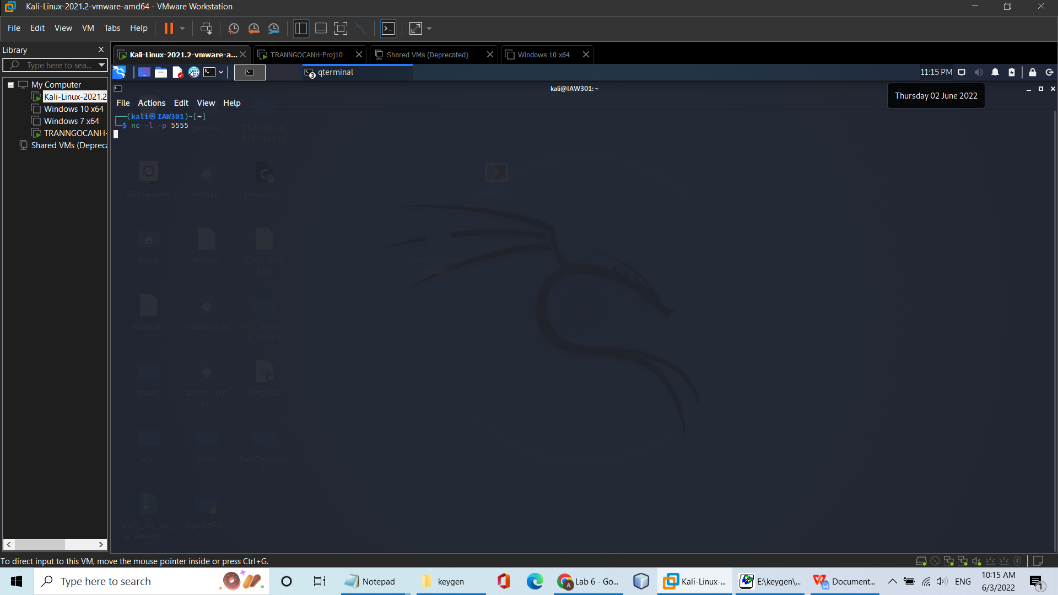

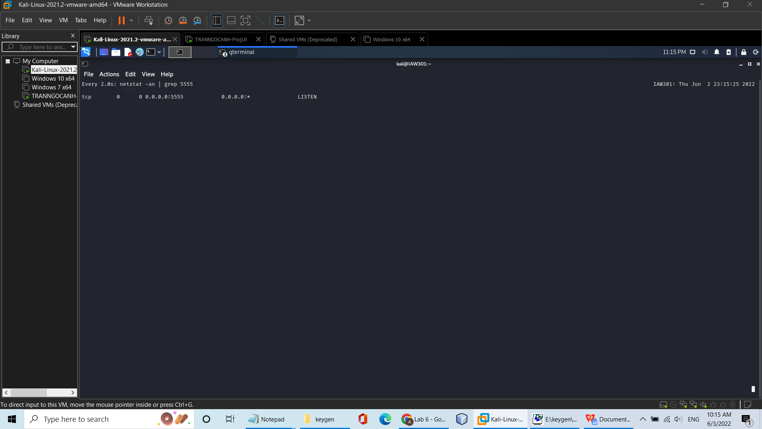

1. **Finding the Target Linux Machine's IP Address**

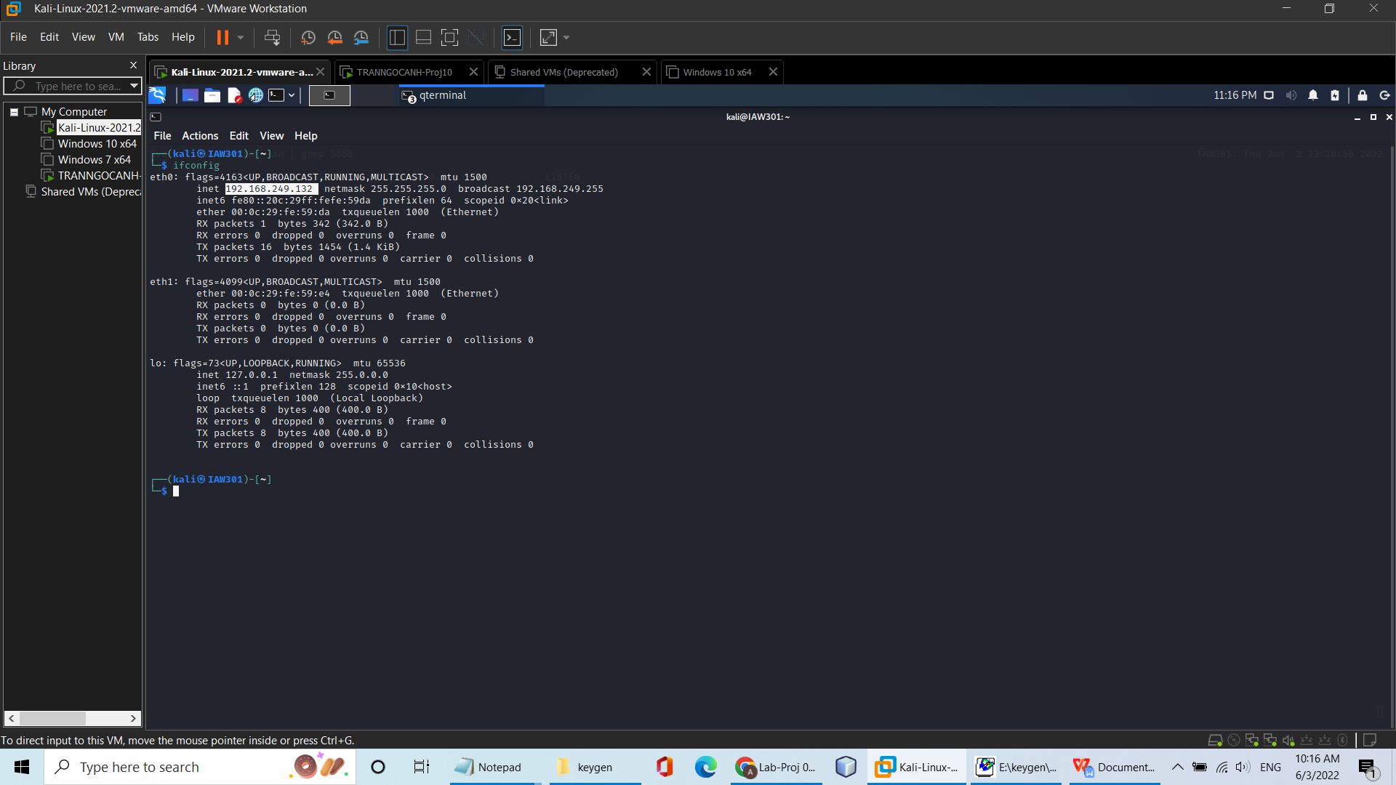

**3)Blocking RST Packets on the Linux Sender Machine**

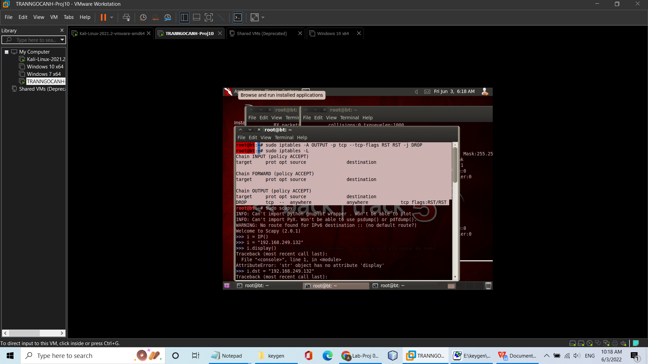

**4)Starting scapy on the Linux Sender Machine**

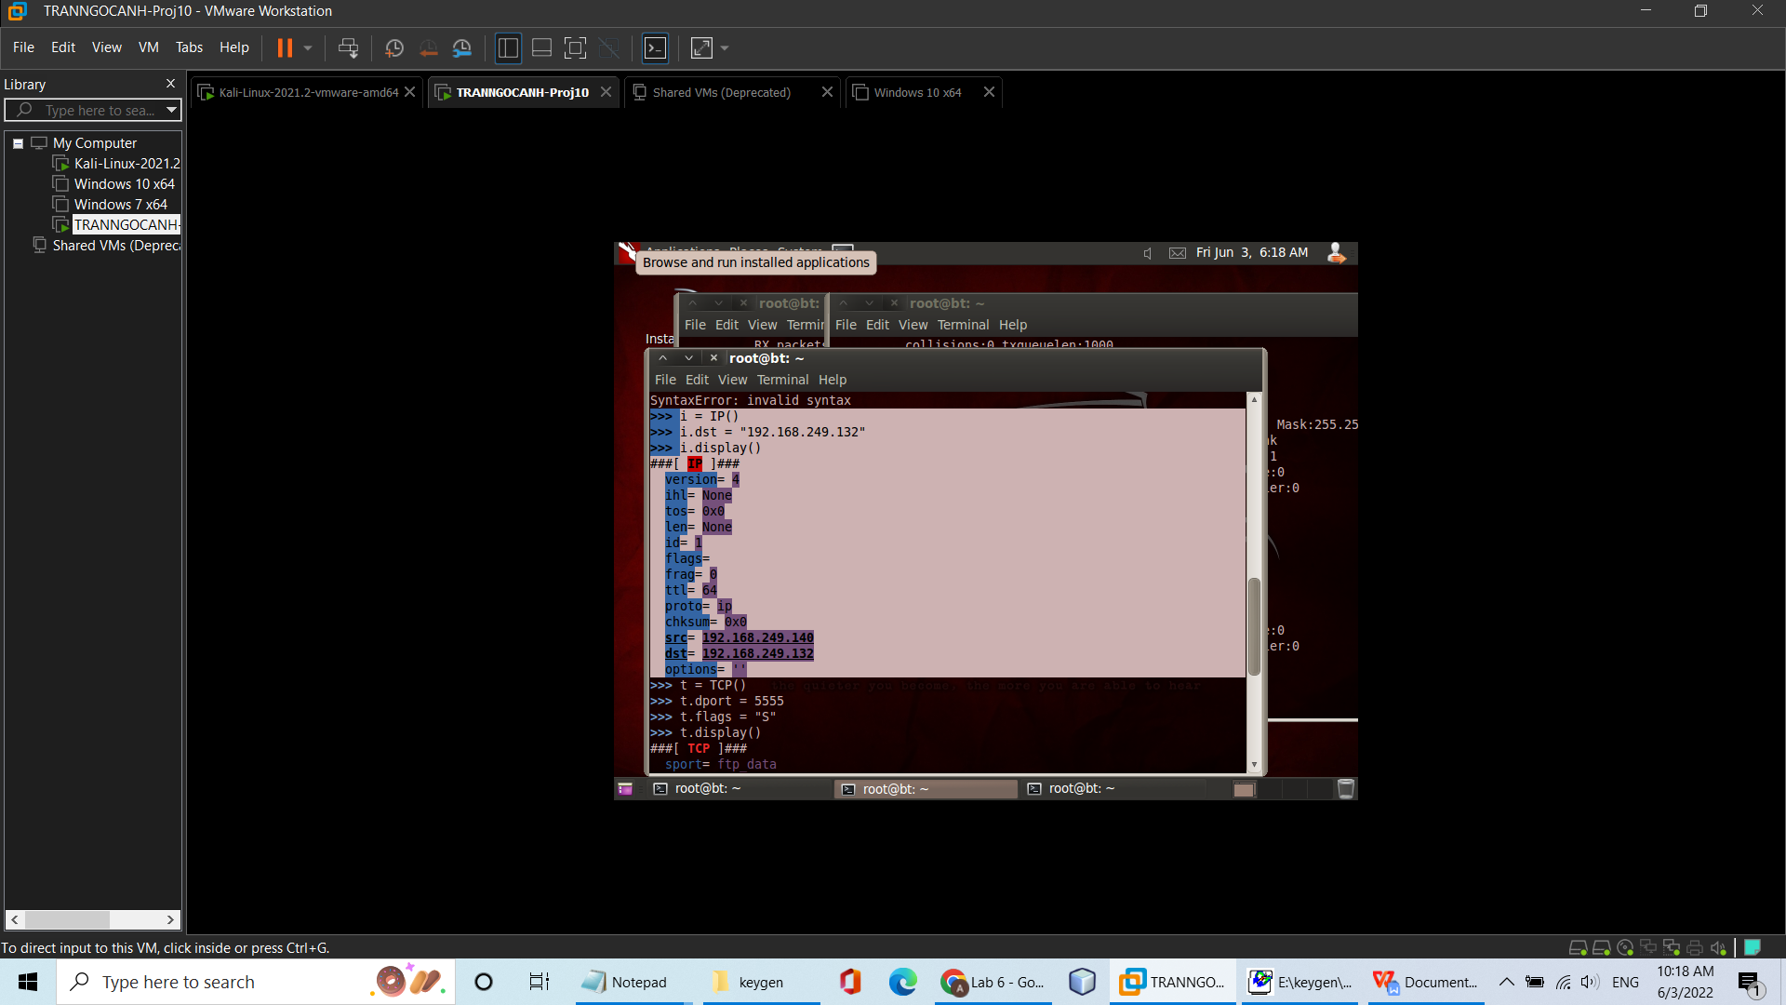

**5)Creating a TCP Object on the Linux Sender Machine**

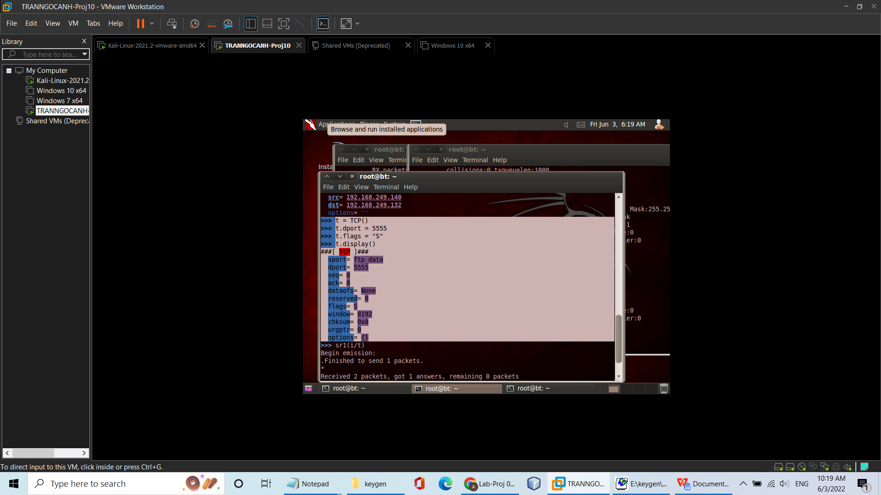

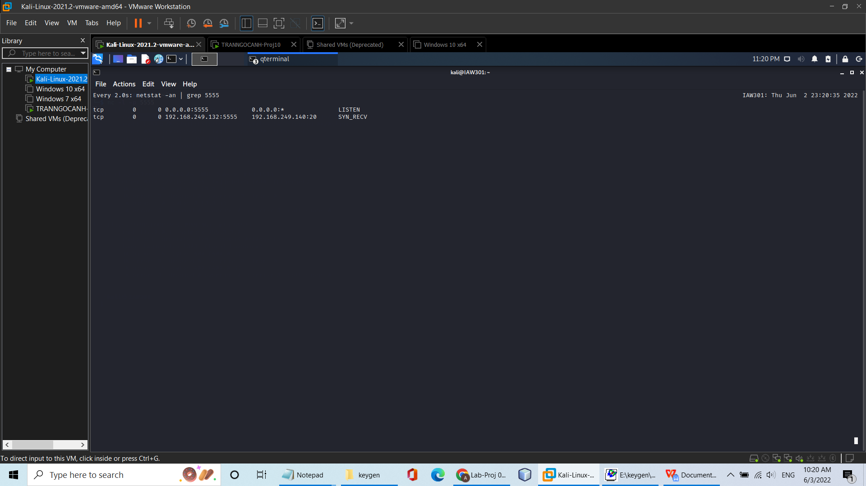

**6)Sending a SYN Packet from the Linux Sender Machine**

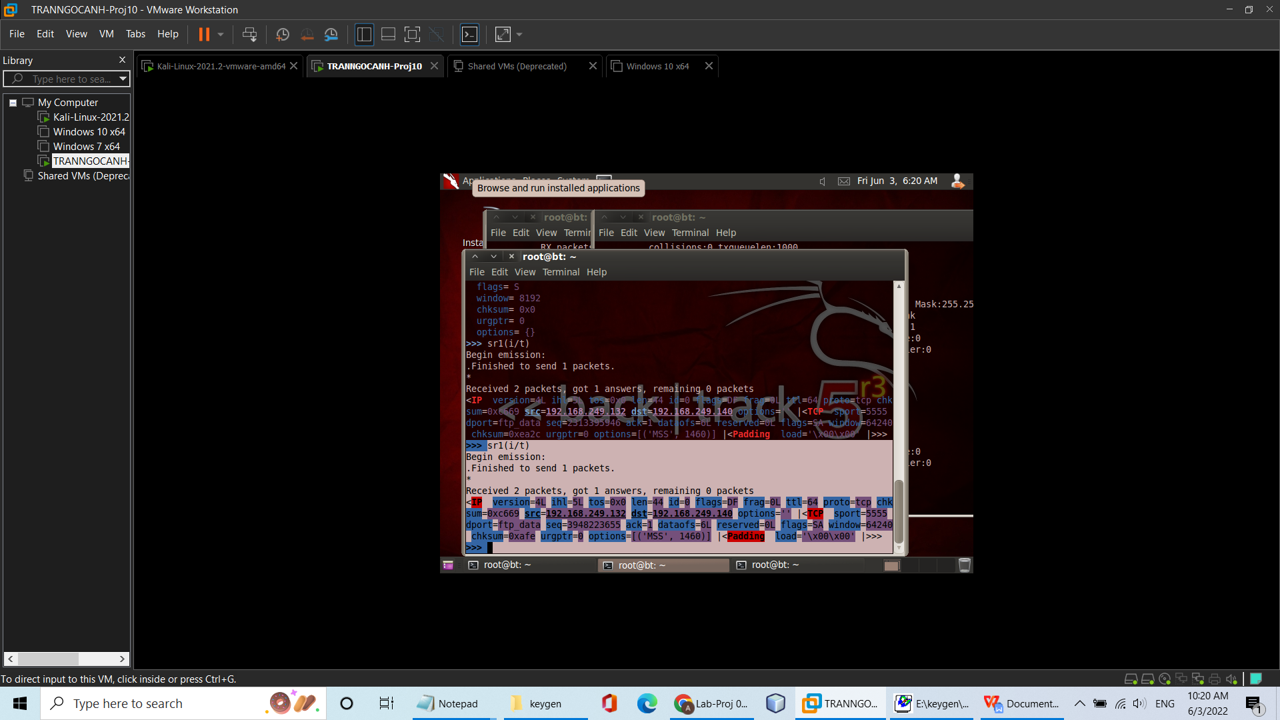

**7)Lengthening the TCP Timeout on the Linux Target Machine**

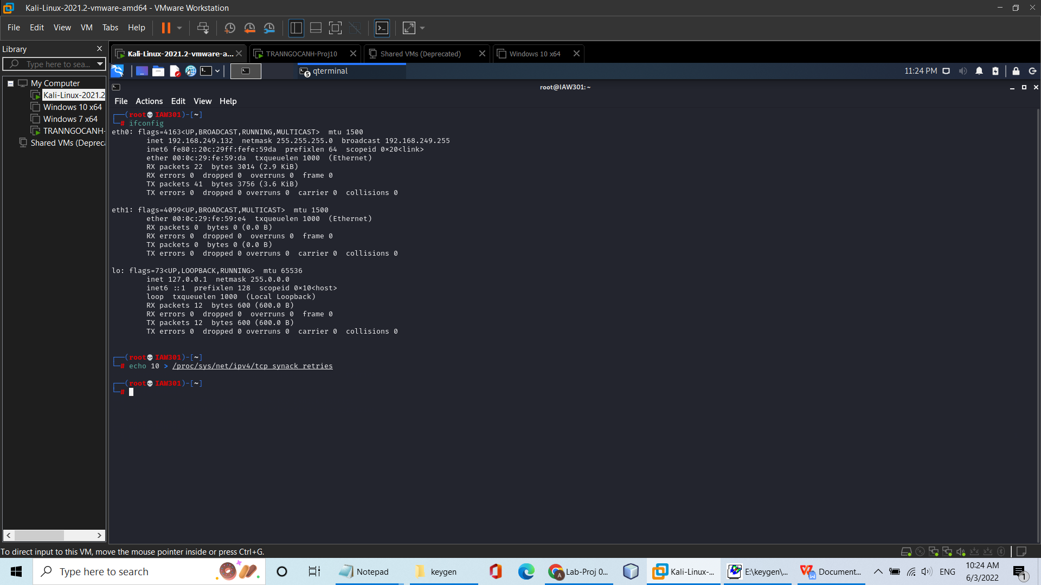

1. **Sending an ACK Packet from the Linux Sender Machine**

